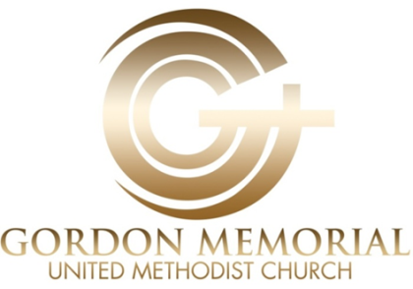

A Christ Centered Compassionate diverse Community

Safe Sanctuary Policy

Introduction and Purpose: Because we believe that Jesus taught us to care for His children and youth, we commit our church to the practice of safe supervision. This policy will set standards for us for the supervision of the children and youth in our care. Thus, in covenant with all United Methodist congregations, we adopt this policy for the prevention of child/youth abuse. Our congregation’s purpose for establishing this Safe Sanctuary Policy is to demonstrate our absolute and unwavering commitment to the physical safety and spiritual growth of all our children.

Statement of Covenant: Therefore, as a Christian community of faith and a United Methodist congregation, we pledge to conduct the ministry of the gospel in ways that assure the safety and spiritual growth of all our children and youth, as well as all those who work with children and youth.

We will follow reasonable safety measures in the selection and recruitment of workers, including keeping applications on file for all workers, paid and volunteer, and completing national background checks for all workers, paid and volunteer. All who supervise children/youth in our church will be at least 5 years older than any children/youth they supervise, and will have been actively involved in our church ministry for at least 6 months. (When youth helpers are used, they will be at least 12 years of age and will be supervised by adults at all times).

We will implement prudent operational procedures in all programs and events including the two non-related adult rule, and an open door policy. No adults will be

alone with just one child or youth at a church-sponsored event. No event/ministry will take place with only one adult present.

We will educate all our workers with children and youth regarding the use of all appropriate policies and the necessity of reporting any allegation of improper behavior.

We will have a clearly defined procedure for reporting a suspected incident of abuse that conforms to the requirements of state law. We will be prepared to respond to media inquiries and the needs of all involved if an incident should occur.

This policy was unanimously adopted by action of Gordon UMC’s Church Council on Thursday, June 19, 2014.

Updated March 2016

Respectfully Submitted:

Angella Current-Felder, Chair Robert Bostick, Vice Chair
Catherine Henderson, Secretary
Reverend Charles L. White, Jr., Senior Pastor

